

**RD INTERNATIONAL SCHOOL, ERODE**

**COMPUTER INVESTIGATORY PROJECT**

**HOTEL MANAGEMENT**

**Guided by: Mrs .KAVITHA. L, PGT (Computer Science)**

DONE BY: ASHWIN XII - D



**CERTIFICATE**



#### CERTIFICATE

This is to certify that the project entitled “**FOOD MANAGEMENT**”

is a record of bonafide work carried out by **ASHWIN.S XII-D**

In partial fulfillment of the requirements in COMPUTER SCIENCE

prescribed by CBSE for 2022 – 2023 in

**RD** **INTERNATIONAL SCHOOL,**

**GATEPUDUR, ERODE.**

#### DATE PRINCIPAL

**INTERNAL EXAMINER EXTERNAL EXAMINER**

# ACKNOWLEDGEMENT

**ACKNOWLEDGEMENT**

We wish to express our sincere thanks to our beloved Founder Chairman **Dr. D.SENTHIL KUMAR**, our Chairman **Mr. S.RAGHUL,** our Principal **Mr. R.SHANKAR** and our institution **RD International School, Erode** for guiding and providing facilities towards the successful outcome of this project work.

### We wish to express our deep and profound sense of gratitude to our guide teacher **Mrs. KAVITHA.L, PGT (Computer Science)**, for her expert help, valuable guidance, comments and suggestions.

We express my heartfelt gratitude to my parents for constant encouragement while carrying out this project.

We also express our sincere gratitude to one and all who directly or indirectly, have lent their helping hand in this venture.

# CONTENTS

|  |  |  |
| --- | --- | --- |
| **CONTENTS** | | |
| **S.NO.** | **TOPIC** | **PAGE NO.** |
| 1 | AIM | 1 |
| 2 | INTRODUCTION TO PYTHON | 2 |
| 3 | INTRODUCTION TO PROJECT | 4 |
| 4 | REQUIREMENTS | 5 |
| 5 | PROJECT ANALYSIS | 6 |
| 6 | CODING | 7 |
| 7 | OUTPUT | 11 |
| 8 | SUGGESTED | 16 |
| IMPROVEMENTS |
| 9 | BIBLIOGRAPHY | 17 |

**AIM**

# AIM

Our project is based on developing a software package for FOOD DELIVERY MANAGEMENT to maintain records of food order details easily. The main motive of this project is to avoid mismatch of records and for easy access of records. This software save time and the special features is that it ensures security.

1

# INTRODUCTION TO PYTHON

**INTRODUCTION TO PYTHON**

Python is a widely used general-purpose, high level programming language. It was initially designed by **Guido van Rossum** in **1991** and developed by **Python Software Foundation**. It was mainly developed for emphasis on code readability, and its syntax allows programmers to express concepts in fewer lines of code. It is used for

* Web development (server-side),
* Software development,
* Mathematics,
* System scripting.

#### BENEFITS OF PYTHON:

* Python can be used on a server to create web applications.
* Python can be used alongside software to create workflows.
* Python can connect to database systems. It can also read and modify files.
* Python can be used to handle big data and perform complex mathematics.
* Python can be used for rapid prototyping, or for production-ready software development.
* Python works on different platforms (Windows, Mac, Linux, Raspberry Pi, etc).
* Python has a simple syntax similar to the English language.
* Python has syntax that allows developers to write programs with fewer lines than some other programming languages.

2

* Python runs on an interpreter system, meaning that code can be executed as soon as it is written. This means that prototyping can be very quick.
* Python has syntax that allows developers to write programs with fewer lines than some other programming languages.
* Python runs on an interpreter system, meaning that code can be executed as soon as it is written. This means that prototyping can be very quick.
* Python can be treated in a procedural way, an object-orientated way or a functional way.
* The most recent major version of Python is Python 3, which we shall be using in this tutorial. However, Python 2, although not being updated with anything other than security updates, is still quite popular.
* In this tutorial Python will be written in a text editor. It is possible to write Python in an Integrated Development Environment, such as Thonny, Pycharm, Netbeans or Eclipse which are particularly useful when managing larger collections of Python files.
* Python was designed for readability, and has some similarities to the English language with influence from mathematics.
* Python uses new lines to complete a command, as opposed to other programming languages which often use semicolons or parentheses.
* Python relies on indentation, using whitespace, to define scope; such as the scope of loops, functions and classes. Other programming languages often use curly-brackets for this purpose.

3

# INTRODUCTION TO THE PROJECT

**INTRODUCTION TO THE PROJECT**

#### INTRODUCTION

This is a free software designed for easy food ordering . This software is a link between the hotel Management employees and the Customer regarding the food menu details. It is a user-friendly software provided with security. It allows the Railway employees to update and delete menu. All train details can be inserted and deleted by the employees and food can be ordered and deleted by the customers.

#### OBJECTIVES OF THE PROJECT

✓ This software helps to have regular track of menu by the Hotel and the

customer orders.

✓ Admin can update and delete menu details.

✓ Here the customers can order a item by viewing the menu details.

✓It has option on pricing details of the food item.

✓It has options for the customer to book and delete food.

4

**REQUIREMENT**

# REQUIREMENTS

#### HARDWARE REQUIRED:

* Processor : PENTIUM(ANY)
* RAM : 512MB+
* Hard disk : SATA 40 GB OR ABOVE
* MOTHERBOARD : 1.845 OR 915,995 FOR PENTIUM 0R MSI

K9MM-V VIA K8M800+8237R PLUS

* CD/DVD r/w multi drive combo: (If back up required)
* FLOPPY DRIVE 1.44 MB : (If Backup required)
* MONITOR 14.1 or 15 -17 inch
* Key board and mouse
* Printer : (if print is required – [Hard copy])

#### SOFTWARE REQUIRED:

* Operating system : WINDOWS 7 AND ABOVE
* Python

5

# PROJECT ANALYSIS

**PROJECT ANALYSIS**

* The project “**FOOD MANAGEMENT**” has 5 modules.

1. Admin:

* Editing the menu
* Adding new customer

1. Customer :

* Viewing menu Items
* Adding menu to the cart
* Reviewing the hotel
* We have initially created an interface between Python and MySQL by installing mysql.connector package to our project interpreter to ease the accessibility.
* We have used various tables to store the user data. The various tables used to store the user data are:
  + Database:

✓food_mangement Database

* + Tables:

✓menu table

✓customer table

✓Admin_details table

6

# CODINGS

**CODINGS**

import mysql.connector

con = mysql.connector.connect(host='localhost', password='root', user='root')

cur = con.cursor()

list_of_command = ['create database food_man;' , 'use food_man' , 'create table admin_info(Id varchar(20) , Passwd varchar(20));' , 'create table menu(Item varchar(20) , price int(4));' , 'create table customer(user varchar(20) primary key, passwd varchar(20) , phone int(10) , purchasedTot int(5));']

try:

    for i in list_of_command:

        cur.execute(i)

        con.commit()

except:

    print('')

    cur.execute('use food_man;')

cur.execute('select * from menu;')

menu = cur.fetchall()

print(menu)

user = str()

passwd = str()

def Admin_session():

    while True:

        print('+--------------------------------------------------------------------+')

        print('|                                                                    |')

        print('|    1) Edit Price of Menu                                           |')

        print('|    2) Add Menu                                                     |')

        print('|    3) Delete Menu                                                  |')

        print('|    4) view Customer Purchased                                      |')

        print('|    5) Exit                                                         |')

        print('|                                                                    |')

        print('+--------------------------------------------------------------------+')

        # print('5) Change Admin Id and Password')

        print('')

        op = int(input('Option :'))

        print('Becarefull the entered data will be affected in the Mysql Database')

        print('___________________________________________________________________')

        if op == 1:

            # Listing the data present in databases

            cur.execute('select * from menu;')

            for i in cur:

                print(i)

            # Reciving new(item and price)

            itm = input('Enter the item name :')

            pric = int(input('Enter the price :'))

            q = 'update menu set price = "%s" where item = "%s" ;'

            fq = q % (pric, itm)

            print(fq)

            cur.execute(fq)

            con.commit()

        if op == 2:

            cur.execute('select * from menu;')

            for i in cur:

                print(i)

            itm = input('Enter the item name :')

            price = int(input('Enter the price of the item :'))

            q = 'insert into menu value("%s",%s);' % (itm, price)

            cur.execute(q)

            con.commit()

        if op == 3:

            # delete from <table_name> where item = dosa;

            for i in menu:

                print(i)

            ite = input('Enter the item should be deleted :')

            q = 'delete from menu where item = "%s" ;' % ite

            cur.execute(q)

            con.commit()

        if op == 4:

            q = 'select * from customer;'

            cur.execute(q)

            data = cur.fetchall()

            for i in data:

                print(i)

        if op ==5:

            break

def customer_session():

    print('_______________________')

    cart = []

    while True:

        #print('YOU HAVE COME TO CUSTOMER_SESSION')

        print('+--------------------------------------------------------------------+')

        print('|                                                                    |')

        print('|    1) Display Menu                                                 |')

        print('|    2) Add Item                                                     |')

        print('|    3) Display Cart                                                 |')

        print('|    4) Delete Cart(Warning This will delete all your item           |')

        print('|    5) Display Total                                                |')

        print('|    6) exit                                                         |')

        print('|                                                                    |')

        print('+--------------------------------------------------------------------+')

        op = int(input('Option :'))

        if op == 1:

            q = 'select * from menu ;'

            cur.execute(q)

            data = cur.fetchall()

            for i in data:

                print(i)

        if op == 2:

            y = 'y'

            while y == 'y':

                ele = input('Enter the Item :')

                q = f'select * from menu where item like "%{ele}%" ;'

                cur.execute(q)

                d = cur.fetchall()

                print(d)

                if len(d) == 1:

                    cart.append(d[0])

                else:

                    ele1 = input('Enter the item from above :')

                    for i in d:

                        if ele1 in i:

                            cart.append(i)

                y = input('Do you want to continu(y/n) :')

                #y = input('Enter do you want to countinue(y/n) :')

        if op == 3:

            print(cart)

        if op == 4:

            cart = []

        if op == 5:

            sum = int()

            for i in cart:

                sum += i[1]

            print('Your sub Total is :' , sum)

            q = f'update customer set purchasedTot = purchasedTot + sum ;'

            print('Successfully You have Purchased :)')

        if op == 6:

            break

def customer_login():

    while True:

        print('+--------------------------------------------------------------------+')

        print('|                                                                    |')

        print('|    1) New Customer                                                 |')

        print('|    2) Old Customer                                                 |')

        print('|    3) Exit                                                         |')

        print('|                                                                    |')

        print('+--------------------------------------------------------------------+')

        option = int(input('Option :'))

        if option == 1:

            print('______________________')

            userName = input('Enter your Name :')

            passwd = input('Set New Password :')

            phone = int(input('Enter the phone number :'))

            try:

                q = 'insert into customer values("%s" , "%s" , %s , null);' % (

                    userName, passwd, phone)

                # print(q)

                cur.execute(q)

                con.commit()

                print('Your data has been add Login from login page again :)')

            except:

                print('This user already exits :(')

        if option == 2:

            print('_____________________')

            global user

            user = input('Enter the User Name :')

            passwd = input('Enter the Password :')

            cur.execute('select * from customer;')

            cu1 = cur.fetchall()

            for i in cu1:

                if (user, passwd) == (i[0], i[1]):

                    print('Success')

                    customer_session()

        if option == 3:

            break

def main():

    while True:

        print('+--------------------------------------------+')

        print('|                                            |')

        print('|    1) Login as Admin                       |')

        print('|    2) View Menu Items                      |')

        print('|    3) Login as Customer                    |')

        print('|    4) Exit                                 |')

        print('|                                            |')

        print('+--------------------------------------------+')

        op = int(input('Option :'))

        if op == 1:

            cur.execute('select * from admin_info')

            for i in cur:

                AdminId = i

            id = input('Enter the Admin id :')

            pas = (input('Enter the Password :'))

            if (id, pas) == AdminId:

                print('Welcome Ashwin :)')

                Admin_session()

            else:

                print('WRONG USER NAME OR PASSWORD :(')

        if op == 2:

            print('MENU')

            cur.execute('select * from menu;')

            for i in cur:

                print(i)

        if op == 3:

            print('WELCOME :)')

            customer_login()

        if op == 5:

            q = input('Enter the qu :')

            cur.execute(q)

            data = cur.fetchall()

            con.commit()

            for i in data:

                print(i)

main()

**OUTPUT**

**OUTPUT**

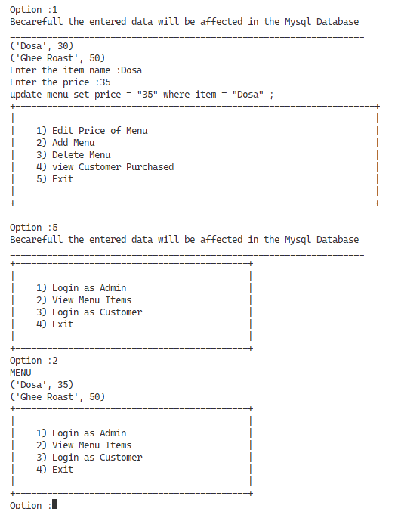

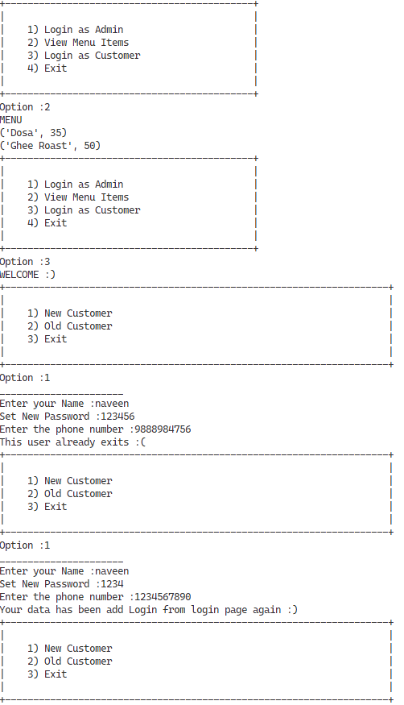

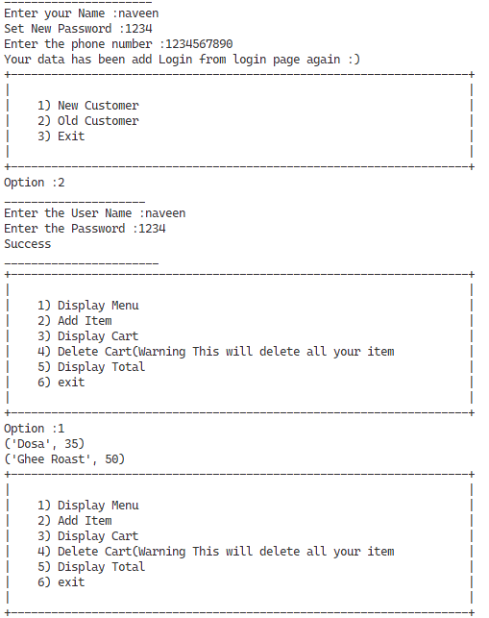

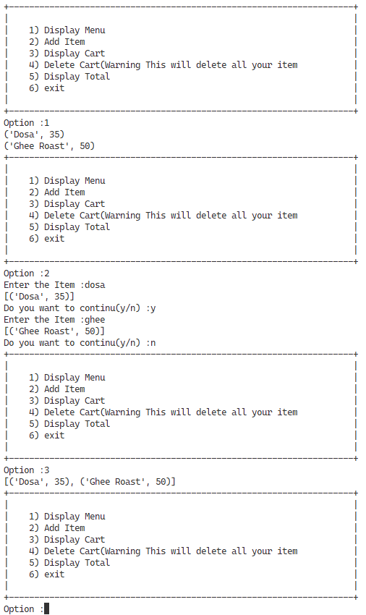

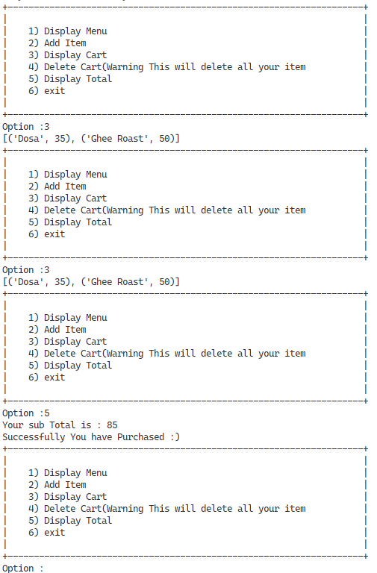

**SUGGESTED IMPROVEMENTS**

**SUGGESTED IMPROVEMENT**

* This is an offline program, in future, it can be developed further as an online application too.
* Providing facilities to attach the attachments can also be implemented in the future to prevent fake accounts and avoid misuse of the software.
* Notifications on remainders can be given regarding and arrival time of food.
* Later, location of food can be tracked by developing Artificial Intelligence software.
* Online payment of food can be done with our intelligence software.
* And to make the usage of the software at more ease and inclusion of Graphic User Interface (GUI) for more elegant and interactive software experience.

16

**BIBLIOGRAPHY**

# BIBLIOGRAPHY

#### BOOKS REFERRED:

Computer science With Python - Class XII By : Sumita Arora

#### WEB SITES REFERED:

Website : https:/[/www](http://www.python.org/).python.org

17